
Express Production Real-time e-VLBI Service
EXPReS is funded by the European Commission (DG-INFSO),
Sixth Framework Programme, Contract #026642

Monthly Report- Jan 2008
Title: | Monthly Report
Sub-title: | - Jan 2008
Date: | 2008 Jan 20
Filename:
Author: | T. Charles Yun, Project Manager, JIVE
Co-Authors | EXPReS Management Team
Summary: | EXPReS monthly update

Delivery Slip
 | Name | Partner | Date | Signature
From | T. Charles Yun | JIVE

Document Log
Version | Date | Summary of Changes | Authors
1.0 | 2008 Feb 08 | Final | tcy
0.1 | 2008 Jan 20 | Initial draft | T. Charles Yun

Project Information
Project Acronym | EXPReS
Project Full Title | Express Production Real-Time e-VLBI Service
Proposal/Contract number | DG-INFSO #026642
Table of Contents
1. Introduction
2. Network Activity Updates
* NA1- Management
* NA2- EVN-NREN
* NA3- e-VLBI Science Forum
* NA4- Public Outreach, Dissemination and Communications
3. Specific Service Activity Updates
* SA1- Production e-VLBI Service
* SA2- Telescope Network Connections
4. Joint Research Activity Updates
* JRA1- FABRIC
5. Appendeces
Section 1.0- Introduction
The Progress and Board meeting were the largest activities for the month. The reporting from activity leaders highlights the work they invested in preparation for that meeting. The meeting helped to summarize the past year’s work for the entire project, but there were also some new announcements and activities that generated interest and discussion.
The process for the next period review has also been set into motion. The Board was informed of conversations between the Project and the Commission. The Project foresees no major obstacles between now and the review.
Looking beyond the project, EXPReS has begun to be noticed on a larger scale. The geodetic community has a large meeting scheduled for June, AOGS 2008. The meeting conflicted with the Annual e-VLBI Workshop, to be hosted in Shanghai. The two groups understand the importance of each meeting and efforts are being made by AOGS (the longer of the two meetings) to push their VLBI related sessions to the end of their schedule so that individuals who want can participate in both meetings.
Additionally, CANARIE recently sent out a news item <http://lists.canarie.ca/pipermail/news/2008/000567.html> highlighting a paper by Oliver Martin (now an independent consultant, previously a prominent networking specialist in the high energy physics community). Martin specifically mentions EXPReS along with LHC, Phosphorus and DESEIA as large scale users of networks.
EXPReS is moving into stage of its project life where interesting things are now happening at a rate a scale that external parties are noticing. This is an exciting time for us and we hope to be able to use and maintain the momentum through the rest of the project.
Section 2.1- NA1 - Management
Progress and Board Meeting
EXPReS held their annual Progress and Board meetings on 29-30 January 2008 at the SURFnet offices in Utrecht, the Netherlands. Meeting minutes and presentations will be posted to the wiki over the next few days.
There were 30 participants at the progress meeting and 11 presentations. There was a disproportionately high representation from the Dutch partners due to the location of the meeting. However, there were updates for each of the activities and informative presentations all around. Specifics are covered in the individual activity updates.
16 of the 19 Board Members were able to participate in person. EXPReS’s two Australian representatives participated remotely via teleconference (the initial intent was a videoconference, but the technology was not cooperating). Hartebeesthoek indicated in advance that they would not be available due to other commitments. The large turnout was extremely useful and allowed for complete discussions on project topics from nearly the full Board.
The most important topic of the Board Meeting involved the discussion of the upcoming period review and changes desired for the DOW. The Board unanimously agreed to request a 6 month project extension and to prepare the final project plan under the assumption that the additional time would be allowed. The project extension was discussed specifically in terms of better organizing and integrating the deliverables and is understood to be an extension in time without request for additional funds.
Standards and e-VLBI: follow up to Concertation
At the 4th e-Infrastructure Concertation Meeting held in Sophia Antipolis, one of the major topics of discussion was the use and development of standards. One of the recommendations of the meeting was for projects to collect information on the standards that are followed in the project. This type of activity is evolutionary by nature; the first step towards it is an investigation into the existing sources of information that are available. The following URLs are already published:
http://www.jive.nl/docs/docs.html
http://www.evlbi.org/user_guide/user_guide.html
These pages are linked prominently from the home pages of each site. Note that JIVE is the coordinating institute for EXPReS and evlbi.org is hosted by ASTRON, JIVE’s sister organization and neighbor. The EXPReS website points to <http://www.evlbi.org/evlbi>.
These two sites describe the astronomical standards and standard procedures as they relate to VLBI and e-VLBI. They do not go into details on the creation process of standards, but document the use of standards.
There are entire classes of standards that are used and not documented. We will move forward with the assumption that some of these do not need to be identified, e.g., the use of TCP/IP for basic network communication. However, there are descriptions of the use of standard network elements that are seen to be new, novel or transient, e.g., SDH, CWDM/DWDM network equipment, and gigabit Ethernet.
A more functional question is how this information will be collected and who the target audience for this information will be. VLBI users (traditional VLBI and e-VLBI) know how to find and use the astronomy information located in the websites above. However, it is unclear how to bridge the gap between network savvy astronomers and astronomy savvy networkers via a webpage (without a human interface). EXPReS is currently approaching a stage in which the astronomy savvy computational-user is colliding with the computationally savvy astronomer. We will face this hurdle on multiple occasions, and the documentation system’s effectiveness will need to be assessed in with an understanding of the effort required to setup and maintain the system compared to the number of potential users of the system.
We look forward to hearing more from other projects who attended the concertation and how they are not only advertising their standards compliance, but also integrating the data of other projects into their day-to-day activities.

Preparation for Period Review
Finally, the Project and the Commission have had several conversations leading to the Period Review. The following summarizes that status of the Project’s understanding. The date of the review is currently planned for the week of Monday 12 May 2008. There is a preference for the Thursday and Friday of that week, but the Project is asking its participants to hold the entire week. The review will be held in Brussels; the exact location will be announced closer to the review.
The commission has indicated that the reviewers will remain largely the same as the Period 1 review. The Commission has identified an alternate reviewer in the case that one of the original reviewers can not participate.
Section 2.2- NA2 - EVN-NREN
There are several items of note from the NREN side of activities this month. First is the potential availability of connectivity for TIGO in Chile. There is a new connection that is being tested that might be available for a demo in conjunction with the TERENA meeting later in the spring. There are several technical hurdles to address before this can be a reality. The timing of this is also coincidental with planned tests with Arecibo. If the timing is good, there may be a possibility to run a demo with Arecibo as well. EVN-NREN has been involved with in discussions surrounding the 4 Gbps Jodrell-Onsala connection.
Section 2.1- NA3 - e-VLBI Science Forum
Call for Proposals
1 February is the deadline for e-VLBI calls (attached as an appendix to this document). This call will be the first since the distribution of the poster used to help advertise the call. eVSAG participated in the design of the poster and shortened the text compared to previous calls.
Board and Progress Meeting
The eVSAG chair attended the EXPReS progress and board meetings at the end of January and gave a report on the development of observing policy during the last year and statistics of submitted and scheduled proposals etc. The eVSAG chair has begun discussions on the organization of the scheduled end of project Science results meeting, most likely to organized in Crete with final date to be decided. Discussion has begun about scheduling the third eVSAG face-to-face meetings (see below).
End Of Project Science Meeting
There is an end of project meeting that would provide a forum for science made possible by EXPReS. During the project extension discussion, an interesting, two-part alternative was suggested.
The first suggestion is to expand the potential participants to people outside of EXPReS. This would include members from LOFAR and other groups that use techniques similar to those used in e-VLBI. The reason to expand the audience is that an internal EXPReS meeting would not disseminate information as much as a multi-project style meeting. While obvious, it is a departure from the initial plan and needs to be officially stated.
The second half of the alternative was to expand the scope of the meeting slightly. Initially, the meeting was an astronomy-science meeting. However, there are important technical-science activities that have taken place during the project. The Board believed that a technical meeting was a good idea and thought that coordinating the meeting with the Science meeting was plausible.
The Board supported both these ideas and will expect to see them as a change recommendations to the DOW in the period update. The possibility of the combined science and technical meeting idea will require further deliberation, most specifically on venue and planning.
Section 2.1- NA4 - Public Outreach
NA4 activities for the current project year were summarized for the Board and Progress Meetings. The update covered items previously reported (press releases, brochure, poster, real-time, correlation map, additional materials) as well as new items (display, merchandise). The display board was the most substantial and substantive item. The display was set up for the meeting participants and a quick demo on setup/tear-down was provided. There are already plans to ship the display to at least three different meetings to help showcase EXPReS activities.
In preparation for the Board Meeting, NA4 partner JBO indicated that their effort in NA4 had been completed with fewer hours than expected. The NA4 activity participants discussed the need for the remaining JOB time in light of the desire for JBO to shift the resources to additional non-dissemination efforts. The decision is that JBO, via the DOW appendix for the period review, will request that the remaining NA4 resources be shifted to other efforts inside of the JBO project space.

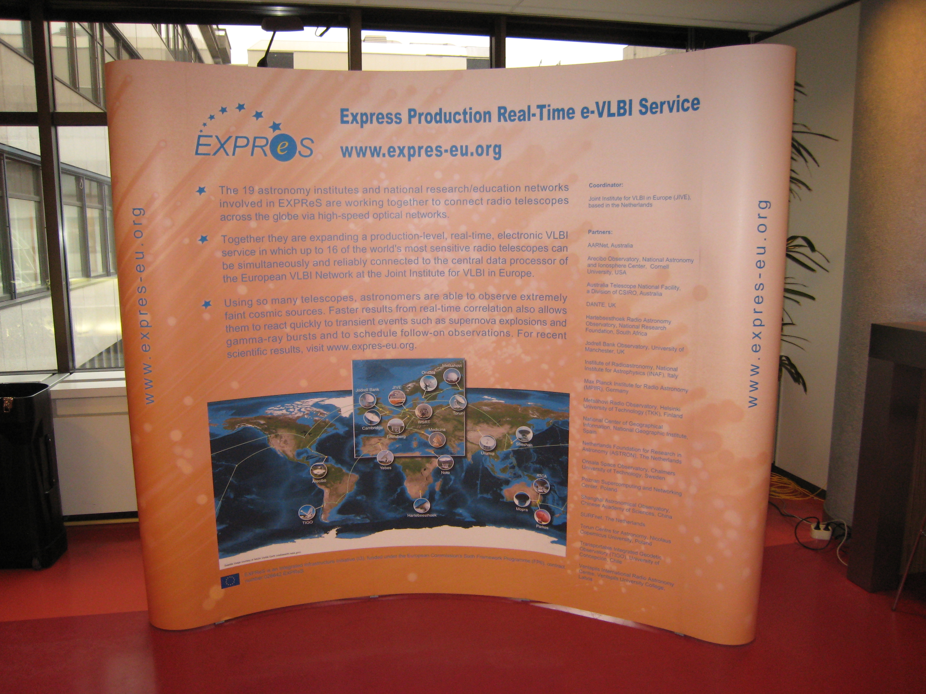
EXPReS Display Board setup at the SURFnet offices, Utrecht, the Netherlands
Section 3.1- SA1- Production e-VLBI Correlation
One e-VLBI session was scheduled for January. As was the case in December of 2007, the trigger for an approved long-term triggered proposal failed to appear and as a consequence no science run was scheduled.
The freed-up observing time was put to good use. Both Onsala and Medecina had recently upgraded the hardware in their Mark5A units, and a fair amount of debugging was needed to iron out a variety of problems. We also took the opportunity to test a new version of the locally developed Mark5A control code, which had a number of modifications to the packet dropping algorithm implemented. These changes make sure that only data packets are dropped at the sending side, while headers remain unmolested. This caused a marked improvement, with the correlator synching right away and remaining in synch, while only dropping 4.5% of the packets. In addition a new script for automatic downloading and installing the jive-mark5 code at the stations was exercised.
Work on enabling e-VLBI with Mark5B progressed slower than we would have liked, as all Mark5 units at JIVE were involved in production correlation; this situation will improve soon and testing will resume.
An end-to-end test of adaptive observing, the ability to change observational parameters during observations, is waiting for telescope time to become available.
Connectivity to the Latvian telescope of Ventspils, a future addition to the EVN, was tested for the first time. Although the telescope site itself is connected at 1 Gbps, some 100 Mbps bottlenecks remain along the way; we expect these to be resolved soon.
The Shanghai radio telescope is getting ready to re-join the e-VLBI effort in 2008, after having been exclusively occupied with the Chinese Lunar probe effort.
A 1 Gbps connection from Effelsberg into GEANT2 was established as well, and first tests will be conducted in February of 2008.
Board and Progress Meeting
During the progress meeting, the evolution and progress of the production correlation system over the past few months was described. The most important elements to note is the building-block style of the individual activities that allow for more interesting and complicated future work. Bob Eldering reported on: the space craft tracking mode, restart a station, Mark 5 e-VLBI emulation, disk interface updates, and Mark5B progress. Individually small, the combination of these activities supports the more intensive e-VLBI activities that are currently in operation and planned. Des Small described work that builds on top of this and supports the move to a more dynamic data flow model of correlation (compared to the traditional batch analysis). Legacy code has been re-written in more modern languages and has been integrated into dynamic workflow and monitoring system. These (and other) activities have increased the operational utility of e-VLBI correlation (reliability, speed, effectiveness).
The improvements in operational correlation will be showcased during a demo at TERENA 2008, Bruges, Belgium. During the same event, there are hopes to be able to run a more ambitious demo between some of the more remote EXPReS partners. Initially, the goal was a 512 Mbps demo with TIGO; the reality of this demo will depend on the suitability of several tools and the availability of a new network connection in South America. More information on this demo will be shared as planning solidifies.
Section 3.2- SA2- Telescope Network Connections
SA2 provided an update to the summary report used to highlight the current state of connectivity for all of the partners. A copy of the 14 December update is posted on the wiki in the SA2 section.
The most important update is the “first light and first fringes” on the Effelsberg high speed data line. Effelsberg is now connected with a 10 Gb data line to the Max Planck Institute for Radioastronomy (MPIfR) in Bonn. Starting from the middle of January 2008, the MPIfR will be connected via a new 1 Gbps line dedicated for e-VLBI to the European research network GÉANT. The first e-VLBI tests between Effelsberg and JIVE are expected for the end of January. They will initially be limited in bitrate due to the 1 Gbit connection.
A first e-VLBI test using Effelsberg, Wettzell and Medicina was made on December 12 and good fringes were found at the Bonn correlator only a few hours later (see figure). The Effelsberg data was sent to the correlator via the new high speed data line; the data from Medicina and Wettzell arrived via Internet and a 1 Gbps test line to the correlator in Bonn.
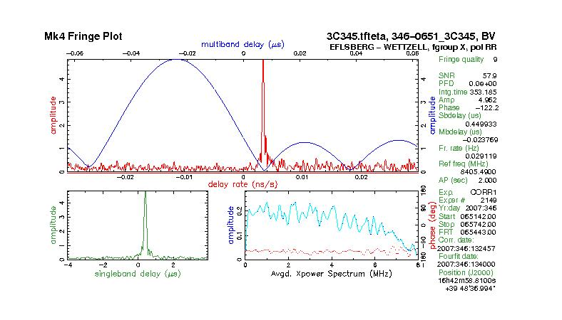
Effelsberg: first fringes via new connection
Onsala
Onsala had its 10G lightpath to Stockholm installed Nov 5th. Onsala has received their iBOBs and iADCs. There are also active discussions for Onsala to used switched lightpaths to in effect send onward from Stockholm 10G lightpath or switched traffic. This will also allow 10G Onsala-Metsahovi tests (needed because the 10G connection from Metsahovi to Helsinki is not a lightpath but is switched traffic).
INAF
In the first days of December the network operators who manage our fiber connection have changed the switch/repeater on the Medicina - Bologna path with a new one that supports jumbo frames. The first memory to memory tests achieved 980-990 Mbps with JIVE. However, the testing revealed “speed holes” in which errors were experienced every 30 seconds. INAF will not be able to support operational traffic at these rates until the problems are resolved. Managers of the GARR/GEANT network have been contact to assist. Finally, the Mark5 unit was upgraded with new CPUs to support faster speeds.
Metsahovi
Metsahovi reports that they have completed the 10 Gbps network setup. The HP switch was delivered and set up. One 10G test PC and one iBOB are connected to the 10 Gbps connection to the Internet. You can find some setup details at http://www.metsahovi.fi/vlbi/instr/10gbps/ - it is a work in progress kind of page.
The Linux test computer is available for remote 10G tests, if those who want to run a 'tcpdump' of incoming iBOB data to RAID-0, or do other similar tests. It is a high-end, gamer, quad-core PC so in theory you could even test realtime software RF channelization and other nifty things.
Section 4.1- JRA1- FABRIC
The FABRIC work package contacted the NRENs JANET,SUNET and NORDUnet regarding connectivity between Onsala and Jodrell Bank to test high data-rate transfers. After an intial meeting at the International eVLBI Workshop in Bonn, work has progressed with a teleconference, dedicated email list and wiki page. To facilitate testing on a short timescale, servers have been located in London and Stockholm and a path configured over GÉANT2 and NORDUnet. It is hoped that, in the near future, the path will migrate to cover the full Onsala-Jodrell Bank route.
Updates from the Board and Progress Meeting
Jodrell Bank reported on progress on their investigations into high speed network protocols. The work will be presented at PFLDNet (Protocols For Long Distance Networking) in March. The presentation summarized investigations into several different TCP variants (including Cubic, High-speed, FAST) as well as an overview of the first look into multicast protocols to support distribution of data.
Jodrell Bank is working with their iBOB and can send data to a PC over a 10 Gbps (CX-4) link at line rate. There is still work in progress with Metsahovi and Onsala on the interfaces and receivers and iBOB to iBOB transfers are in progress. Overall, progress with iBOBs is moving forward quite well. The next tasks including measurements on packet statistics (loss, duplication, etc) and optimization of time fields.
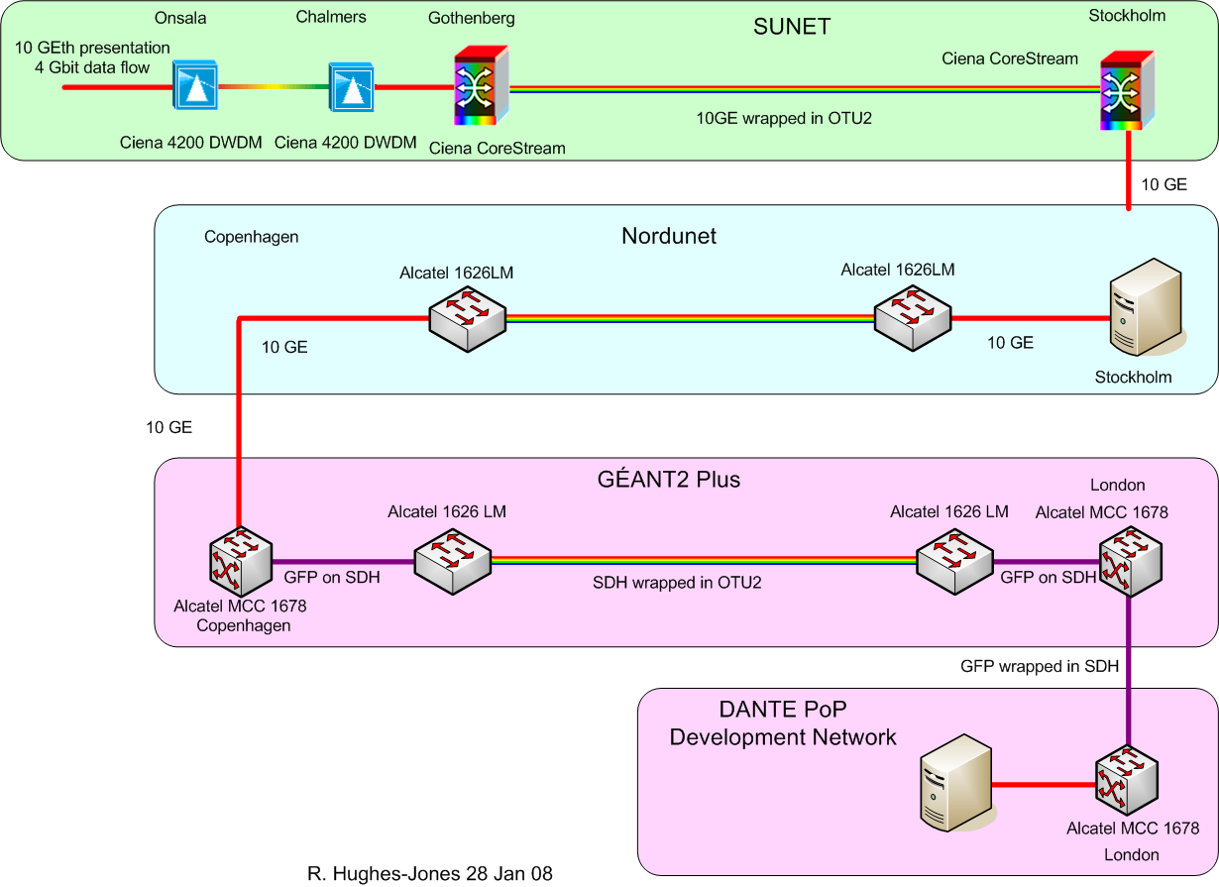
Schematic of the GEATN2-NORDUnet-SUNET connection
The 4 Gbps test with SUNET and NORDUnet is underway. Participants have met, and have organized around a wiki and created a requirements document. The links are currently in place and available. Unfortunately, the December 2007 test failed due to problems between NORDUNet and DANTE. The problem is being investigated and new tests will be scheduled. There were positives from the test, including finding that UDP worked well across a large portion of the connection up to 4.2 Gbps.
The software correlator update touched upon mostly known items, but did highlight some significant recent activities and details. The SFXC system has implemented interfaces JSON (Java Script Object Notation) based control files for the correlation parameters. The entire system has been designed to be modular and uses MPI to be able to scale well to larger clusters. Current optimization efforts include an effort to use single precision units (all are currently double precision) and implement CPU specific vector libraries. These two efforts should have significant improvements in overall speed with no visible effect on results. An additional optimization is to modify the FFT process, but this would change data, albeit in an extremely minor way. The effect of this change is being investigated.
Appendix - EXPReS Contact Points
For convenience, a list of the activities and the associated contact points are listed here for reference.

ID | Description | Contact | email
PC | Project Coordinator | Huib Jan van Langevelde | langevelde // jive nl
NA1 | Management of I3 | T. Charles Yun | tcyun // jive nl
NA2 | EVN-NREN Forum | John Chevers | john.chevers // dante org uk
NA3 | e-VLBI Science Forum | John Conway | jconway // oso chalmers se
NA4 | Public outreach | Kristine Yun | kyun // jive nl
SA1 | Production Services | Arpad Szomoru | szomoru // jive nl
SA2 | Network provisioning | Francisco Colomer | f.colomer // oan es
JRA1 | FABRIC | T. Charles Yun | tcyun // jive.nl
Appendix - Short Topic on Video Conferencing
Videoconferencing- Short Topic Paper
2008 February 6
Version 0.6

Contents
Introduction
Information Gathering
Experiences (1-5)
Local Issues
Remote Issues
Summary
Appendix 1:

INTRODUCTION
At the First EXPReS Annual Review, the EXPReS Project was encouraged
to pursue and implement videoconferencing as a way to enhance and
compliment existing communication pathways. To this end, the project
has pursued and tried several different solutions. This document
briefly summarizes the activities of the past year.

INFORMATION GATHERING
Following the First Annual Review, the Project Manager distributed an
email asking for feedback on videoconferencing. He asked specific
individuals if they used videoconferencing systems and if they were
interested in using video more frequently as a means of communicating
within the project.

Following these pointed emails, the Project Manager sent email to the
project partners as a whole. The email asked for information on the
availability and, if applicable, type(s) of videoconferencing systems
available to each partner site. The feedback from this email shows
the wide range and lack of general support of video across different
institutions.

Table 1: Preferred videoconferencing systems

SYSTEM NAME NUMBER OF VOTES
accessgrid/VRVS 4
webex 2
skype 2
isabel 2

As you can see, there is no clear majority tool and a wide range of
tools are used. We do note that some of the tools are ale to
communicate with multiple types of systems.

EXPERIENCE 1: SECOND BOARD MEETING
The first use of videoconferencing after the Annual Review was the
Second EXPReS Board Meeting. At this meeting, the majority of the
board members were co-located in Helsinki. The meeting venue in
Helsinki was a designed videoconferencing room, with multiple
cameras, overhead projectors and microphones for the audience.

One caller participated via video and another participated via
telephone conference call. The system used was Skype.

During the meeting, the video participant was not able to send video.
The participant could receive video and maintain two-way audio to the
meeting. The belief is that firewall issues on the participant’s
side caused issues, but this was not be confirmed.

Overall, the co-located board members and the two remote participants
were able to communicate through the meeting. However, the technical
difficulties were obvious and the amount of up-front test time was
deemed onerous for the short meeting and number of remote
participants.

EXPERIENCE 2: Skype and Correlator Operators
After discussing the problems with Skype inside of the project, the
correlator operators indicated that they regularly use Skype's audio
and instant messaging system to communicate. They pointed out that
audio plus text chat was generally sufficient for their needs. They
did not have plans to test video.

EXPERIENCE 3: USING ISABEL
One of the project members participated in a remote presentation
using the ISABEL videoconferencing system. The site had problems
with Skype previously, but ISABEL worked without problem. The ISABEL
system is based on an UBUNTU boot CD and thus requires non-Linux
users to have a spare machine available to mediate the video
conference.

It is important to note that the success of the videoconference was
largely due to advanced testing before the meeting. This meeting had
a large support network which would not normally be available to an
EXPReS-specific meeting.

EXPERIENCE 4: AD HOC, H.323 MEETING USING EVO
In an effort to test ad hoc capabilities and different tools, a small
group decided to have a quick video meeting using EVO. The
participants were varied in location and platform.

Table 2: Ad hoc videoconference test breakdown

user platform connection
1 Mac OS X Office LAN/100 Mbps
2 Mac OS X Office wireless/802.11 g
3 Windows XP Office LAN/100 Mbps
4 Mac OS X 802.11g over home DSL

Overall, the meeting went extremely well. The problems encountered
were mostly logistic: there was no testing prior to the meeting,
there was no explanation of the somewhat complicated UI for EVO and
email was the backchannel communications. In spite of the
difficulties, all parties were able to connect, sending and receiving
both audio and video. As the test went on, the bandwidth limited
user form home learned to drop video from non-essential participants
to improve overall performance (this would mimic only watching a
single speaker instead of attempting a dynamic, multi-party
conversation).

A difficulty arose from one participant being in a server room and
introducing too much noise into the conference. When that user muted
audio, the quality of the experience for all users, including the
bandwidth limited user, improved dramatically. Later it was learned
that an organizer should be able to mute remote participants
centrally to address issues such as this.

Also as expected, the home wireless/DSL user had the most difficulty
maintaining useful connectivity. As mentioned, a passable solution
was found for the user.

In summary, EVO "worked" out of the box, but it was difficult to tell
at first due to non-system induced problems. Again, advanced testing
should be able to quickly sort out these problems.

EXPERIENCE 5: EXPRES BOARD OF DIRECTORS MEETING
A videoconference was planned for the Third EXPReS Board of Directors
meeting, held in Utrecht at the end of January 2008. The meeting was
to gather a majority of the board members in person, with members
from Australia and South Africa indicating that they would try to
connect via video. In the end, a telephone conference line was
opened for the duration of the meeting as video failed completely.

The failure mode was slightly different this time. We suspect that
video would have worked; unfortunately, the meeting room had recently
been "upgraded." The first problem was that a cabinet was locked, so
we could not find the power switch for the video system. Once that
was addressed, we realized that a minor change was needed on the
videoconferencing unit to connect to a different GDS and no one had
the password for the video unit. A separate, mobile unit was brought
it, but the meeting was being delayed, so the group decided to simply
use a speaker phone instead of waiting to set up the mobile video
unit.

There was some confusion from the remote sites as well. There is a
chance that one of the remote participants would not have been able
to connect due to firewalls issues. However, we did not have a
chance to investigate this matter.

In hindsight, advanced testing should have addressed this problem.
The organizers did attempt to schedule test times, but none of the
remote sites were able to participate. Fortunately, there was a
backup that worked well enough for the rest of the meeting.

LOCAL ISSUES FOR JIVE
The R&E network infrastructure controlled by different group than
operational IT infrastructure. Specifically, desktop network ports
and the videoconferencing budget are external services not under
project control. This means that EXPReS does not directly control
videoconferencing hardware/support and changes to the existing system
require at least a year for requests to enter the budgeting cycle.
The advent of built-in and portable video cameras has improved the
situation somewhat. However, firewall issues continue to be
problematic.

Moving videoconferencing to the project controlled network
infrastructure is a possibility, but would introduce significant
political tension. Taking on responsibility for the larger
videoconferencing system might make the system support group happy,
but would introduce an unwieldy (and largely inappropriate) burden
onto the scientists. We hope that we can synchronize and coordinate
the next stages of videoconference system planning.

REMOTE ISSUES
During the survey for preferred tools/systems, it was evident that
many institutes made significant investments into hardware several
years ago. Many of these systems were not compatible and thus, not
used. Some institutes are thus hesitant to invest in new
videoconferencing solutions until a clear "correct choice" is
evident. Even when the installed hardware system exists, getting
access to the system is not guaranteed. There are clear chicken-
egg/bootstrapping problems here.

Open standards and systems can come to the rescue here. AccessGrid
is one such system and was indeed the most commonly used system.
However, AG is understood to be fairly difficult to administer.

VRVS (and the subsequent EVO project) is another related system that
acts as a bridge between different types of video systems and
protocols. The mediation capability of these tools makes the author
believe that they are the easiest near-term solution for users (in
terms of connectivity). Ease of use remains to be seen for all of
the systems.

SUMMARY
From our past year's effort, we have not been able to seamlessly
integrate videoconferencing into our day to day activities. Part of
this may be habit. There is some evidence that technical factors out
of the control of individual users are also an issue. When there
were successful conferences, overall enthusiasm was relatively low
since things "just worked."

The most important element to success seems to be early testing of a
system. We suspect that selecting a system that will be used
consistently over time will also aid in the testing and
familiarization process.

EXPReS will continue to investigate using videoconferencing as an
potential collaboration technology.

APPENDIX 1: Links to videoconferencing and collaborative tools
AccessGrid: http://www.accessgrid.org/
EVO: http://evo.caltech.edu/
ISABEL: http://isabel.dit.upm.es/mediawiki/index.php/vf
Skype: http://www.skype.com/
VRVS: http://www.vrvs.org/
WebEx: http://www.webex.com/

Appendix – Call for EVN e-VLBI Science Proposals
The following email was distributed to advertise the upcoming e-VLBI call.
CALL FOR EVN e-VLBI SCIENCE PROPOSALS - DEADLINE 1st FEBRUARY
--------------------------------------------------------------
Proposals for EVN eVLBI observations are invited for submission. New
features include;

* 512Mbit/s bit rate from at least a six station array at most EVN
observing bands, lower bit rates for spectral line observations are
also supported.

* Proposals for any science goal, not just rapid response science can
be made. Combination with disk based observations in standard sessions
is possible for denser time monitoring of variable sources.

* Additionally a special class of 'triggered' e-VLBI proposal is defined
in which a pre-approved project can be activated within 24 hours
of a scheduled eVLBI run based on a trigger criterion being met.

* eVLBI can also be used for EVN Target-of-Opportunity (ToO) observations
set up at short notice on any date. Such proposals can be
submitted at any time in response to a high priority unanticipated
astronomical event. For details see the
EVN ToO policy at http://www.evlbi.org/proposals/too.nov07.pdf
---------------------------------------------------------------------------
Scheduled e-VLBI runs for which observations can be proposed for the
February 1st EVN deadline are;

Run start Run end

Tue 8th Apr 13:00 UTC Wed 9th Apr 13:00 UTC
Tue 20th May 13:00 UTC Wed 21st May 13:00 UTC
Tue 24th Jun 13:00 UTC* Wed 25th Jun 13:00 UTC*

(Note * indicates a provisional date to be confirmed). In the second half
of 2008 eVLBI runs are likely to scheduled at approximately the same rate
of one every 6 weeks between disk sessions. Participating EVN antennas
include Wb14 (tied array, except 5cm), Tr, On, Mh, Mc, Jb2, Cm and (for
some runs for limited UT times and bitrate) Ar. Wavelength bands
covered are 18/21cm, 6cm, 5cm and 1.3cm. Please see
http://www.evlbi.org/evlbi/e-vlbi_status.html for the availability of
different eVLBI stations per observing band. Note that because of
on-going engineering work participation of Jb2 and Cm cannot be
guaranteed and/or they may be replaced by other MERLIN telescopes.
---------------------------------------------------------------------------
TECHNICAL DETAILS

CONTINUUM OBSERVATIONS - will be run at the highest possible reliable
bit rate. Based on recent experience it is expected that 512 Mbit/s
is very likely to be achieved (however Cm is presently limited to
128 Mbit/s of useful data by its microwave link, and Ar to the same
total bitrate by its link). Continuum observations can be proposed for
only one of the available frequency bands in any given 24hr session.

SPECTRAL LINE OBSERVATIONS - can be carried out at recording rates
between a minimum of 32 Mbit/s and a maximum of 512Mbit/s. For two-bit,
dual-polarisation observations, the lower limit implies at least
4 channels of 4 Msample/sec sampling (Nyquist channel bandwidth = 2MHz;
with oversampling possible down to spanned channel bandwidths of 0.5MHz).
Observations may be proposed for the 18cm/21cm, 5cm and 1cm bands.
Note that only standard and short observation proposal types (see below
for definitions) are allowed for spectral line observations. Triggered
spectral line proposals will not be accepted.
-------------------------------------------------------------------------
e-VLBI OBSERVATION CLASSES

eVLBI proposals submitted for the use of eVLBI on the fixed dates defined
above fall into the three classes defined below. Time within the first two
classes will only be allocated in response to proposals submitted for the
standard EVN proposal deadlines of 1st Feb, 1st June and 1st Oct. PI's
should make clear in the proposal text which class of observation is
being requested.

1) General e-VLBI proposals

Any proposal requesting e-VLBI observing time during one or several
e-VLBI sessions, excluding triggered response science (see below).
General eVLBI proposals can be any scientific purpose and do not need to
be justified based on the rapid data delivery of eVLBI. Proposals
for source monitoring may also request complementary observing time
during regular EVN sessions using disk recording. Note that the eVLBI
portion of monitoring proposals cannot be guaranteed in every requested
run as they may be overridden by higher rated, triggered e-VLBI proposals
(see below). General eVLBI proposals can be either continuum or spectral
line. Scheduling will be done by JIVE staff using the technical
information included in the proposal; it is therefore vital that all
technical aspects are fully specified in the proposal.

2) Triggered e-VLBI proposals

A proposal to be scheduled during an e-VLBI run only if a specific
triggering criterion is met. Accurate source coordinates need only be
included in the trigger request, not the original proposal. Only
continuum observations can be proposed for within this class.
Triggered proposals must include a precise and justified
triggering criterion and a minimum number and configuration of
telescopes required.

PIs of successful proposals in this class will be informed after
proposal review that their trigger requests will be accepted. Such
trigger requests should be sent by e-mail to the EVN PC Chair (Patrick
Charlot <charlot@obs.u-bordeaux1.fr>) with copies to the EVN Scheduler
(Richard Porcas <porcas@mpifr-bonn.mpg.de> and JIVE/EXPReS
(Bob Campbell <campbell@jive.nl>, Zsolt Paragi <zparagi@jive.nl>).
These trigger requests must be received no later than 0800 UT
the day before the eVLBI run. The email should provide evidence that
the trigger criterion in the original proposal has been met and
give the exact GST range and source position requested. All requested
technical parameters must match those in the original proposal.
The PC Chairman will evaluate the trigger request (and decide on
priorities if more than one conflicting trigger request is received) and
will inform the PI by 1700UT whether their experiment is to be observed.
The experiment will then be scheduled by JIVE staff in accordance with
the instructions given in the original proposal.

3) Short e-VLBI observations

Short e-VLBI observations may be requested for checking calibrator or
target source compactness in preparation for a larger VLBI observation
or proposal. These projects are limited to less than 2 hours in length.
Such requests may be submitted up to three weeks prior to the start
of any e-VLBI run directly to the EVN PC Chairman. There is no need
to submit a full proposal via Northstar but the email to the Chairman
must clearly indicate the purposes and observing details of the proposed
observation including all information needed for scheduling (including
position information of targets and calibrators).
-------------------------------------------------------------------------
PROPOSAL DETAILS

Proposals requesting observing time for the above runs should
be submitted by the 1 February 2008 deadline. Proposals can be made for
any length of time within the above advertised slots up to 24 hours in
length. Short time requests (defined above) of up to 2 hours in length
can be submitted directly to the PC Chairman up to three weeks before
each run. Proprietary rights on all eVLBI data are the standard ones
of one year after data distribution (see archive policy at
www.evlbi.org/user_guide/archive_policy.html). All standard and
triggered proposals must use the Northstar online submission tool
(see details below).

Because detailed scheduling of eVLBI runs will be done by JIVE staff
all eVLBI proposals must include the observing frequency, the requested
GST range, the minimum bit rate and a minimum number and configuration
of telescopes required. It is essential that standard proposals also
include accurate target and calibrator positions. For triggered proposals
as much information as possible should be given about potential targets
and their calibrators, which will ease in evaluating the technical
feasibility of the proposed observations. The technical details of
all proposals should be discussed with JIVE staff prior to submission to
ensure proper and efficient scheduling (contact campbell@jive.nl).
-----------------------------------------------------------------
HOW TO SUBMIT

The on-line proposal submission tool Northstar replaces the old
Latex-email way of submission for proposals which involving the
EVN, including proposals for e-VLBI runs (an exception to this
at present are ToO proposals which are submitted by email according
to the procedure described at http://www.evlbi.org/proposals/too.nov07.pdf).

To use Northstar proposers should register at http://proposal.jive.nl
(only for the first proposal submission), complete the technical information
on-line (equivalent to that previously in the cover-sheet) and upload
a scientific justification in pdf or ps format. Standard page limitations
apply and will be enforced. If advice is needed about submitting via
Northstar please contact Cormac Reynolds (reynolds@jive.nl) or other JIVE
staff. The deadline for submission of standard and triggered proposals
is 23:59:59 UTC on 1st February 2008.
-----------------------------------------------------------------------
ACKNOWLEDGEMENT

The continuing development of e-VLBI within the EVN is made possible
via the EXPReS project funded by the EC FP6 IST Integrated infrastructure
initiative contract #026642 - with a goal to achieve 1 Gbit/s e-VLBI real
time data transfer and correlation.
--------------------------------------------------------------------
John Conway - Chairman EVN eVSAG (eVLBI Science Advisory Group)

